What is PBIS?

Positive Behavior Interventions and Supports (PBIS) is a proactive systems approach to establishing the behavioral supports and social culture and needed for all students in a school to achieve social, emotional, and academic success.

As a Response to Intervention model, PBIS applies a three-tiered system of support, and a problem-solving process to enhance the capacity of schools to effectively educate all students.

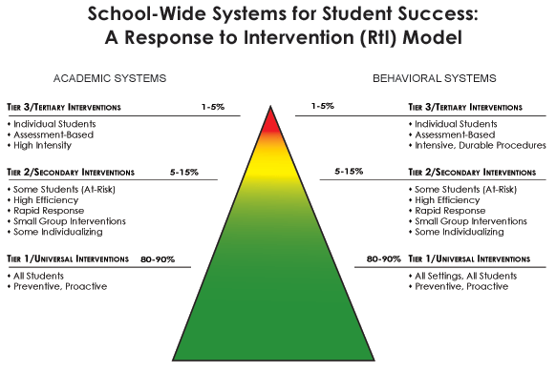
RTI
PBIS

Data-based decision-making aligns curricular instruction and behavioral supports to student and staff needs. Schools applying PBIS begin by establishing clear expectations for behavior that are taught, modeled, and reinforced across all settings and by all staff. This provides a host environment that supports the adoption and sustained use of effective academic and social/emotional instruction. PBIS has proven its effectiveness and efficiency as an Evidence-Based Practice. (Sugai & Horner, 2007).

The principles and practices of PBIS are consistent with federal education mandates such as the No Child Left Behind Act (NCLB) and the Individuals with Disabilities Education Act of 2004 (IDEA 2004). PBIS integrates state school improvement initiatives including Systems of Support, Standards Aligned Curriculum, and Response to Intervention to assist schools in meeting Illinois’ educational goals and mandates.
PBIS is:
Prevention-based : Through instruction, comprehension, and regular practice, all stakeholders use a consistent set of behavioral expectations. These expectations are included in our Owl Motto:

Owls
Will Show Respect
Live Responsibly, and be
Safe

Data-based : School teams within the building review data on individuals and groups of students to determine which students are not responding to the teaching of the behavioral expectations. PBIS schools view it as an opportunity for re-teaching.

Community-based : PBIS offers supports for families, youth, and schools.

Research-based : The school-wide PBIS process emphasizes the creation of systems that support the adoption and implementation of evidence-based practices and procedures fitting within on-going school reform efforts.
Why is it so important to focus on teaching positive social behaviors?
In the past, school-wide discipline has focused mainly on reacting to specific student misbehavior by implementing punishment-based strategies including reprimands, loss of privileges, office referrals, suspensions, and expulsions. Research has shown that the implementation of punishment, especially when it is used inconsistently and in the absence of other positive strategies, is ineffective. Introducing, modeling, and reinforcing positive social behavior is an important step of a student's educational experience. Teaching behavioral expectations and rewarding students for following them is a much more positive approach than waiting for misbehavior to occur before responding. The purpose of school-wide PBIS is to establish a climate in which appropriate behavior is the norm.
What is a systems approach in school-wide PBIS?
An organization is a group of individuals who behave together to achieve a common goal. Systems are needed to support the collective use of best practices by individuals within the organization. The school-wide PBIS process emphasizes the creation of systems that support the adoption and durable implementation of evidence-based practices and procedures, and fit within on-going school reform efforts. An interactive approach that includes opportunities to correct and improve four key elements is used in school-wide PBIS focusing on: 1) Outcomes, 2) Data, 3) Practices, and 4) Systems. The diagram below illustrates how these key elements work together to build a sustainable system:
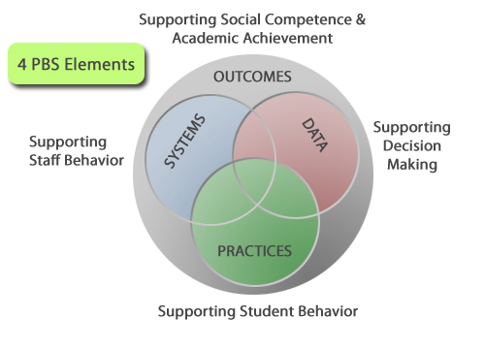
- Outcomes: academic and behavior targets that are endorsed and emphasized by students, families, and educators. (What is important to each particular learning community?)
- Practices: interventions and strategies that are evidence based. (How will you reach the goals?)
- Data: information that is used to identify status, need for change, and effects of interventions. (What data will you use to support your success or barriers?)
- Systems: supports that are needed to enable the accurate and durable implementation of the practices of PBIS. (What durable systems can be implemented that will sustain this over the long haul?)

